May 2014



May 2014 Dooblo Newsletter
I am happy to share that our CEO, Ofer Heijmans will be presenting at this year’s CASRO Technology & Innovation Event, to be held on Wednesday, May 28 and Thursday, May 29, 2014 at the Radisson Blu Aqua Hotel in Chicago. Ofer will be presenting the “Tablets Killed the Paper Star” session on Wednesday, May 28, 3:25 P.M. - 3:55 P.M.
Under the “Jagaad! Tech Innovation Around the Globe” track. If you are attending the event we will be happy to see you among the session participants and please come over and say ‘Hi’ before or after the session.

The Productivity Sessions Materials are now published and available for you to view!
As you know this year we started delivering productivity webinar sessions on specific topics that we think may interest you and contribute to your ability to get more out of SurveyToGo.
The last session was regarding Interview GPS Location Capturing and how you can enhance your quality control and field work management by making sure the interviews are done where you planned them to happen.

We published the Webinar materials and you can find them under: GPS Location Capturing and Geo Fencing

Upcoming Webinar Session
Next session: Durations and Time Capturing in SurveyToGo - Enhance your quality control by making sure the interviews are done with durations as you planned them to happen
A great way to enhance the quality control of interviews is to measure and review the interview duration that is automatically captured and associated with the interviews (and other manually added durations of specific interview parts). You can ensure that interviews are done within expected durations and identify exceptions based on average durations.

You can read more about how SurveyToGo captures times here: http://support.dooblo.net/entries/22400618-The-different-time-fields-captured-with-SurveyToGo

To join a live session where we will discuss the topic and demonstrate it as part of SurveyToGo Register Here

Solution Focus - Operational Dashboards
Operational Dashboards: Fieldwork Reports and KPIs
In addition to the standard product offering, SurveyToGo includes a few super productive premium add-on features that can greatly enhance your fieldwork.
The Operational Dashboards allow you to easily view several key performance indicators of your running survey. You can use these KPI’s to evaluate whether your project is running on track and determine the throughput of your field staff. The Fieldwork reports allow you to easily view various reports related to your fieldwork and more importantly allow you to generate custom reports based on the operational data of your project.

KPIs
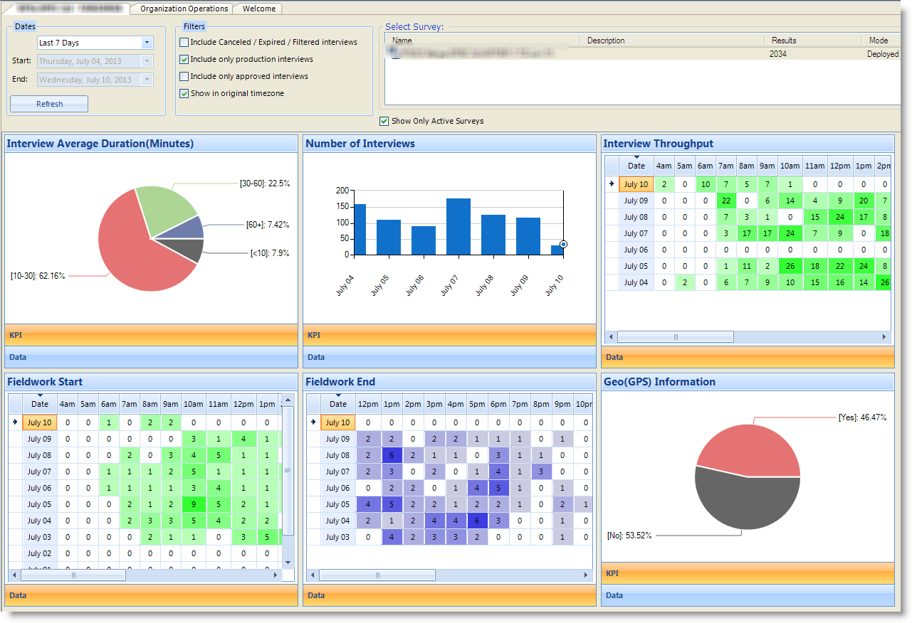

Fieldwork Reports
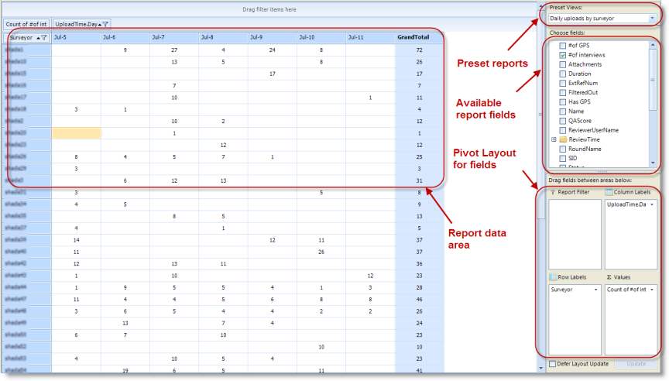

More information can be found here:

KPIs: http://support.dooblo.net/entries/26975571-How-to-Using-the-Operational-Dashboards

Fieldwork Reports: http://support.dooblo.net/entries/26979752-How-to-Using-the-Operational-Dashboards-Fieldwork-Reports

SurveyToGo Support Portal SurveyToGo Functions Document SurveyToGo How-To’s
SurveyToGo Video’s SurveyToGo Manual SurveyToGo Portal Sign Up

