December 2013



December 2013 Dooblo Newsletter
As we approach the holidays the Dooblo family wishes to congratulate you with Happy Holidays and a Happy New Year!

Product Highlights
Dummy Data Generator: Easily get your Data Processing team prepared for the collected data before even conducting one interview
In most organizations, In parallel to scripting a questionnaire, the Data Processing team is getting prepared for the data analysis of the interviews that will be collected when the survey gets out to field.
How much testing effort do you invest in creating test data for your DP team to review before signing off a script?
Has your DP team ever requested that you provide them with more than just 10 test interviews to review?
How many times did you face a situation where there was no time to generate data for the DP team before going live and DP was not happy with the results structure delivered when interviews started coming in from the field?
When creating complex surveys most customers will focus on the script logic accuracy and if time is left will also collect enough test interviews so that the data processing department can review the collected test data (and may require adjustments to the script before going into field).
A great way to enhance this phase is by utilizing the “SurveyToGo Dummy Data Generator” that enables you to automatically generate tens or hundreds of test interviews and then export them into your preferred data format.
The SurveyToGo Dummy Data Generator is an add-on feature that enables you to:
- Set the amount of test-interviews to generate
- Run the test with or without validation rules
- Fine tune the answers and weights of random answers if necessary
- Export the test data to all supported formats
- Does not “eat up” any of your interview balance

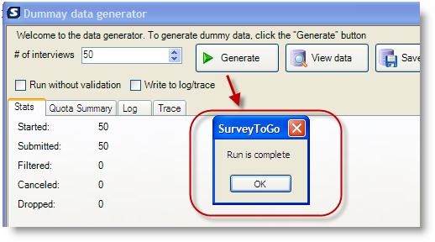

You can read more about the benefits of the Dummy Data Generator and understand how it works here: Using the SurveyToGo Dummy Data Generator

To Join a live session where we will demonstrate the Dummy Data Generator please Register Here

Surveys Template Library
We are continuing to add demo surveys for common scenarios to the support portal, you can find links to the recent ones in this newsletter and in the SurveyToGo Support Center:
Surveys Template Library

Scripting Techniques
Calculating Total Net Interview Duration:
The duration you see when looking at an interview in the exported data is a calculated value that is derived by subtracting the time Captured upon starting the interview from the time captured upon completing the interview. This includes of course the entire duration of the interview including the times the interviewer stopped and exited to perform other tasks. In the following scripting sample you can find a way to calculate the Net time the interviewer was working on the interview and keeping it as a value that can later be exported and consulted:
Calculating an Interview Net Duration

Function Library
We continue updating our function library document to include more descriptions and examples. Here’s the latest version of the documentation: SurveyToGo Functions Doc

‘How-To’, Tutorials & Videos
We recently issued an updated version of the User Guide (Manual). This is a live document and we will keep updating and adding more information into it as the solution progresses. You can find the updated User Guide here:
The SurveyToGo User Guide

Here you can find some of the latest How-To’s and tutorials we have added to our knowledge base in the past month:

- Your Most Important Resources
- Survey Structure and Configuration
- Android Configuration Options
- Calculating Total Interview Duration with Save Resume
- SurveyToGo Supported Platforms
- How-To Install SurveyToGo Studio on Additional Computers

SurveyToGo Support Portal SurveyToGo Functions Document SurveyToGo How-To’s
SurveyToGo Video’s SurveyToGo Manual SurveyToGo Portal Sign Up

